**Atlanta Professional Dance Academy**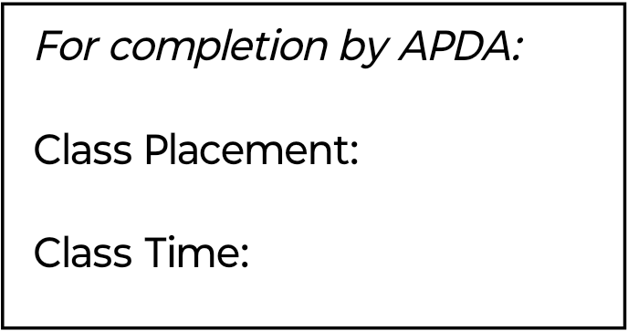

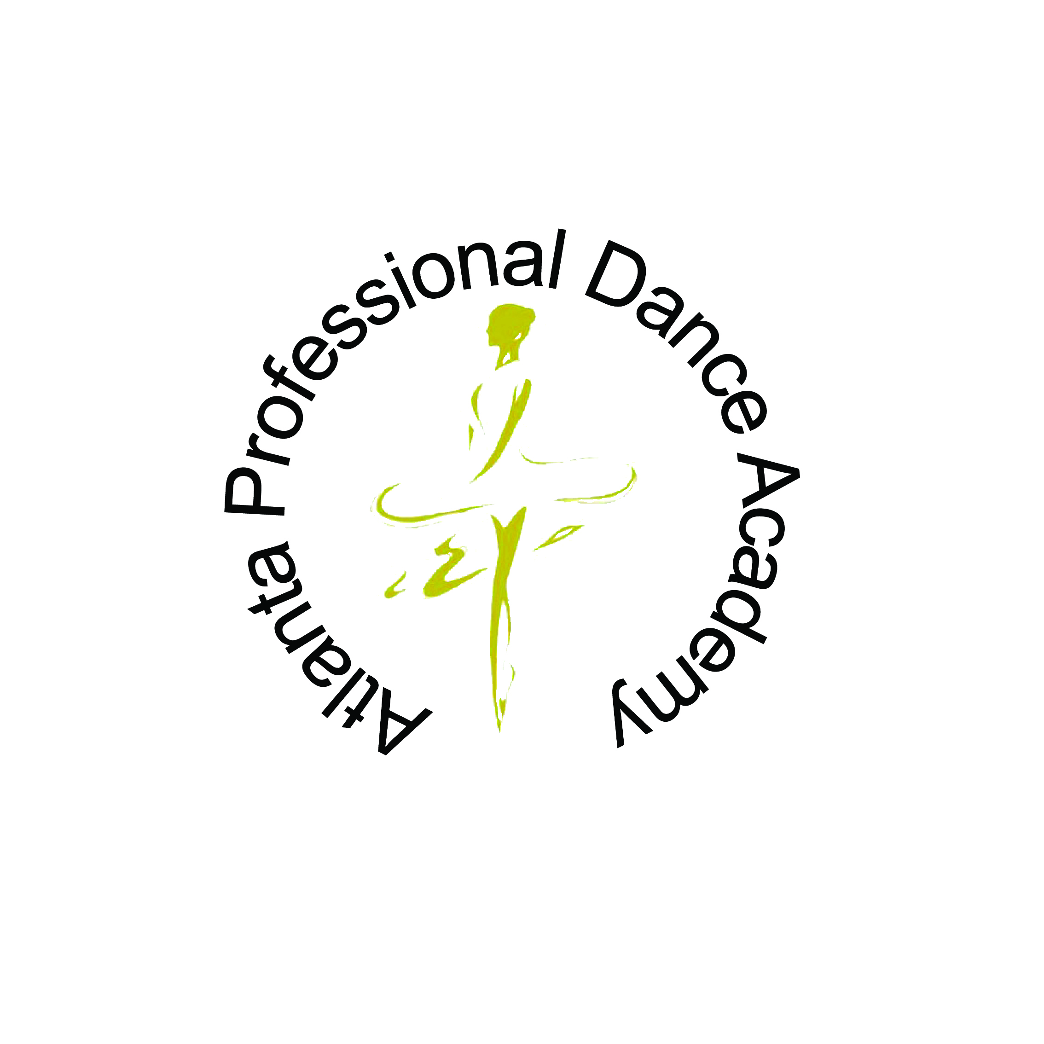

***Zhang Yao, Artistic Director***

**www.APDAdanceacademy.com**

**2025-2026 REGISTRATION**

Please complete and return with the $25.

Annualregistration fee. The feeis **Non-refundable**.

Checks should be made payable to:

APDA or Zelle to 770-524-5133

Mail or deliver to:

The Atlanta Professional Dance Academy

10700 Abbotts Bridge Road, Suite 100

Johns Creek, GA 30097

PLEASE PRINT:

Student: ___________________________________________

First Middle Last

Date of Birth: ________________________ Age: __________

Academic school or preschool attending: _________________________________________________

Home Address: ____________________________________

City: _______________________ State: _____ Zip: ________

Mother’s Name: __________________ Cell: _____________

Father’s Name: __________________ Cell: ____________

Home Phone: _________________________

Email Address:

_________________________________________________

If new, how did you learn about our school?

_________________________________________________

If new, previous dance school and experience (years and type)

_________________________________________________

Emergency Information

Contact: _______________________ Phone: ____________

**APDA must be advised of pre-existing medical conditions before class starts. Please note here**:

_________________________________________

**Office Use Only:** Date:

Annual Reg. Fee Enclosed Check #:



ENROLLMENT OPTIONS:

___ Full year payments (5% discount for paying in full)

___ Monthly payments (Due on 5th of each month/$25) late)fees)

**Levels: Hours & Tuitions:**

**Class level and age Hours per Week Monthly Cost**

Level I /5-6 years old 2 hours $168

Level II /7-8 years old 3 hours $228

Level III /9-11 Yrs. old 4 hours $288

5 hours $340

Level IV /12-13 Yrs. old 6 hours $384

Level V /14-16 Yrs. old 7 hours $420

Level VI /17-18 Yrs. old 8 hours $448

Intensive Class 9 hours $468

10 hours above/unlimited class $480

**Special Training (Walk-in Conditioning) class:** $10/hour

**Single Class Rates (1 hrs.):** $25

**Private Class:**

**None APDA students** $165/per hour (Tuition + Studio)

APDA students 1:1 $90/per hour

1:2 $70/per hour/per dancer

1:3 $55/per hour/per dancer

1:4 $45/per hour/per dancer

THERE IS 5% TUITION DISCONT FOR SIBLINGS AND

PAID IN FULL FOR THE SEASON. (NO COMBINED DISCOUNT)

PAYMENTS:

Zelle, Check and Cash are preferred. No Credit Cards.

$30 fees charge for bounced check. Please write the student’s name on the check. All Zelle payments to 770-524-5133

**PLEASE READ THE APDA RULES AND REGULATIONS ON THE BACK OF THIS FORM BEFORE SIGNING BELOW.**

**Signature is required for registration.**

**My signature below acknowledges I have read, understand, and agree to comply with these rules, regulations and agreement.**

Signature: _____________________________ Date_______

Parent or Guardian for students under 18

Questions:

Contact 770-524-5133 or 770-310-3037 Ms. Di

Email: ludi7701@gmail.com



The Atlanta Professional Dance Academy

10700 Abbotts Bridge Road, Suite 100

Johns Creek, GA 30097

770-524-5133

www.APDAdanceacademy.com

**ATLANTA PROFESSIONAL DANCE ACADEMY (APDA)**

**RULES AND REGULATIONS/AGREEMENT**

**______ ENROLLMENT: Students may enroll at any time during the year. APDA offers a one-time complimentary class for new students as an evaluation/placement class. After being accepted, new students will receive their class placements and sign up for the rest of the school year.**

**______ TUITION:** APDA follows Fulton County school calendar for fiscal years. This agreement is for all school years. For walk-ins, monthly tuition is due before class starts. If enrolled year-round, payment is due on the fifth of each month. A $30 fee is charged for returned checks. **A late fee of $25 is charged if tuition is paid after the 5th of the month**. 5% discount if paid in full for the full season or siblings (no combined discount), the 5% discount includes missing classes for any reason during the year. Tuition checks may be handed to the **Principal Ms. Di Lu** in person or Zelle to 770-524-5133. Please make sure to write your student’s name on the check or in the Zelle memo. The monthly tuition covers 4 weeks each month; the 5th week in the calendar is a balance week for makeup classes during the school year. **APDA takes all Fulton County school holidays off with tuition charge, including but not limited to Labor Day, Thanksgiving, Christmas, and New Year.** No refunds will be issued for missed classes, regardless of the reason. If the school cancels a class, students will receive either a make-up class or account credit for the missed session within the same academic year. The APDA reserves the right to make final decisions regarding the interpretation of these terms and conditions.

**______ PERFORMANCES AND FEES**: **Performing in productions is encouraged but not mandatory. A non-refundable performance fee is required for each performance in which the student participates. A rental fee for all costumes is provided by the school.** All costumes remain the property of the Academy. Parents and/or students are responsible for obtaining posted rehearsal information. Students who miss rehearsals for any reason (including illness) to the extent that they cannot perform adequately may be excluded from the performance by notice of the Artistic Director and the Principal.

**______ WITHDRAWAL or TERMINATION**: If a student needs to withdraw from the classes, a written notice must be provided by the parents at least 30 days in advance. Tuition is required for those 30 days. There is no discount, credit, or refund for withdrawal, termination, or missed classes. The Academy reserves the right to terminate any student who fails to follow the school rules or for other disciplinary reasons.

**______ ATTIRE**: Proper attire must be worn during class according to the Academy’s dress code. Copies of the dress code will be distributed and posted at the Academy. Hair must in bun for all female dancers.

**______ CLASS OBSERVATION**: Classes may be observed from the observation windows. Parents are not allowed in the classroom during classes as it is a distraction to the students.

**______ MEDICAL**: The Academy must be advised of any pre-existing medical conditions. In the event of a medical emergency, if the parent or guardian cannot be contacted, the Academy will seek emergency medical treatment unless otherwise advised in writing at the time of enrollment by the parent or guardian.

**______ PHOTOGRAPHS/CAMERA FOOTAGE**: The Academy reserves the right to use photos or live camera footage taken of the students by the Academy or media for display, publications or other publicity, including the website and social media.

**______ RELEASE AND WAIVER OF LIABILITY**

The signer of this registration acknowledges that participation in risk-oriented programs and activities involves the possibility of physical injury and allows the student to perform in these programs and activities, assuming all liability. The T.M. Culture & Arts Center and the Atlanta professional Dance Academy are released by the students, parents or guardians from all liability for any injuries incurred or arising from the student’s participation in any dance activities or events on our campus or at locations and events off campus. Each participant in the activity of T.M. Culture & Arts Center (TMCAC) and the Atlanta Professional Dance Academy (APDA) classes should realize that there is body contact between teachers and students, inherent risks. Hazards and dangers involved include training, preparation for and travel to and from such activities. It is the responsibility of each participant to engage only in those activities and programs for which he/she has the prerequisite skills, qualifications, preparation, and training. THIS PROVISION APPLIES TO ALL THE CLASSES OFFERED BY THE T.M.C.A.C AND APDA SCHOOL IN ALL LOCATIONS and RENTAL SPACES.

The TMCAC/APDA does not warrant or guarantee in any respect the competency or mental or physical condition of any trip leader, vehicle driver, instructor, or individual participant in any competition, performance, athletic, recreational, adventure program or workshop.